Firmware Implementation 2
1. Title 2
2. Objective 2
3. Theory (Multi-Level) 2
3.1 Beginner — Simple Intuition 2
3.2 Intermediate — Engineering View 2
3.3 Advanced — Signal/Architecture Level 3
4. Architecture / Concept 4
Firmware Build Flow 4
Application Logic (fw/main.c) 5
Register Access in Assembly (Generated by Compiler) 5
5. Implementation 5
Files in This Module 5
Firmware Size Analysis 6
6. Lab / Hands-on Section 6
Step 1: Build Firmware 6
Step 2: Inspect the Compiled Firmware 7
Step 3: View ROM Hex Content 7
Step 4: Run SoC with this Firmware 7
Step 5: Verify Firmware is Loaded 7
7. Waveform / Verification Insight 7
Instruction Fetch Trace 7
UART TX Activity 8
Firmware String in ROM 8
8. Common Issues & Debug Tips 8
Verify RISC-V ABI with objdump 8
9. Summary 9

Firmware Implementation
Course: PicoRV32 SoC with AXI-Lite & UART Integration
Lab Commands: make fw → make soc_pico_uart_mem

1. Title
Firmware Implementation — Writing Embedded C for PicoRV32, UART, and AXI-Lite SoC

2. Objective
By the end of this module, learners will be able to:
- Write bare-metal embedded C firmware for a RISC-V SoC with no OS
- Understand startup code (crt0.S) and linker scripts (link.ld)
- Implement UART driver functions using memory-mapped register access
- Compile firmware using riscv32-unknown-elf-gcc toolchain
- Convert firmware binary to ROM hex format for simulation and synthesis

3. Theory (Multi-Level)

3.1 Beginner — Simple Intuition
When you write C code for a PC, the operating system provides everything: printf(), file access, memory management. When writing firmware for a bare-metal RISC-V SoC, there is no OS. You must:
- Set up the stack yourself (where does the CPU put local variables?)
- Write directly to hardware registers using fixed addresses
- Build a tiny “stub” (crt0.S) that runs before main()
Think of it like writing a recipe where you also have to build the kitchen from scratch.

3.2 Intermediate — Engineering View
Bare-metal firmware components:
Component | File | Purpose
C runtime startup | fw/crt0.S | Initialize stack, call main(), trap on exit
Application code | fw/main.c | Application logic (UART echo)
Linker script | fw/link.ld | Map code/data to ROM/SRAM addresses
Firmware Makefile | fw/Makefile | Compile → link → objcopy → bin2hex
Hex converter | fw/bin2hex.py | Convert binary to 4-byte-wide hex for $readmemh
Memory layout (from fw/link.ld):
MEMORY {
ROM (rx) : ORIGIN = 0x00000000, LENGTH = 32K
SRAM (rwx) : ORIGIN = 0x00010000, LENGTH = 8K
}
SECTIONS {
.text → ROM (0x0000_0000): code + read-only data
.data → SRAM (0x0001_0000): initialized global variables
.bss → SRAM : zero-initialized globals
Stack : top at 0x0001_00FC (descends)
}
UART register macros (fw/main.c):
#define UART_TX (*(volatile char*)0x10000000)
#define UART_RX (*(volatile char*)0x10000004)
#define UART_STATUS (*(volatile int*) 0x10000008)
volatile is mandatory — it prevents the compiler from caching the register read in a CPU register and bypassing the actual memory-mapped access.

3.3 Advanced — Signal/Architecture Level
Startup Sequence (crt0.S → main()):
# crt0.S: executed before main()
_start:
# 1. Initialize stack pointer
lui sp, %hi(__stack_top)
addi sp, sp, %lo(__stack_top)
# __stack_top = 0x0001_00FC (from link.ld)
# 2. Zero-initialize BSS section
la a0, __bss_start
la a1, __bss_end
bss_loop:
bgeu a0, a1, bss_done
sw x0, 0(a0)
addi a0, a0, 4
j bss_loop
bss_done:
# 3. Call main
call main
# 4. Trap if main returns (should not happen)
_exit:
j _exit

Compilation flags:
CFLAGS = -march=rv32i -mabi=ilp32 -nostartfiles -nostdlib
-T link.ld -Wall -O2
- -march=rv32i: Target RV32I base ISA (no multiply/float — matches ENABLE_MUL=0 in PicoRV32)
- -mabi=ilp32: 32-bit integer, 32-bit pointers ABI
- -nostartfiles: Don’t link GCC’s crt0 (we provide our own)
- -nostdlib: Don’t link libc (we implement everything ourselves)
ROM hex format (rom.hex): Each line is one 32-bit little-endian instruction word in hex:
00020137 ← LUI x2, 0x20 (first instruction: setup stack pointer upper)
FFC10113 ← ADDI x2, x2, -4
...

4. Architecture / Concept

Firmware Build Flow
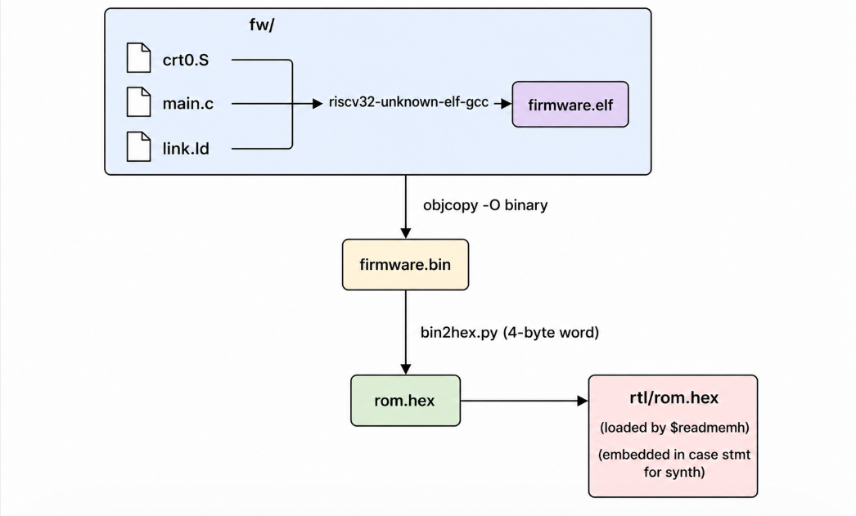

Application Logic (fw/main.c)
main()
│
├─ for i = 0..9:
│ uart_puts("Hello Deepak from Nielit!\n")
│ └─ uart_putc(each char)
│ └─ UART_TX = char [→ AXI write to 0x10000000]
│
└─ while(1): ← Echo loop
c = uart_getc()
│ └─ while(!(UART_STATUS & 0x2)); [poll 0x10000008]
│ return UART_RX [read 0x10000004]
│
uart_putc(c)
└─ UART_TX = c [→ AXI write to 0x10000000]

Register Access in Assembly (Generated by Compiler)
For UART_TX = 'H' (C store through volatile pointer):
lui a0, 0x10000 # a0 = 0x10000000
li a1, 'H' # a1 = 0x48
sb a1, 0(a0) # store byte → mem[0x10000000] = 0x48
# mem_wstrb = 0x1 (byte store)
For uart_getc() status poll:
lui a0, 0x10000 # a0 = 0x10000000
lw t0, 8(a0) # t0 = mem[0x10000008] = STATUS
andi t0, t0, 2 # check bit 1
beq t0, x0, -8 # if not ready, loop
lb a0, 4(a0) # return mem[0x10000004] = RX byte

5. Implementation

Files in This Module
File | Purpose
fw/main.c | Application: greeting + echo loop (201 lines, well documented)
fw/crt0.S | Startup: stack init + call main + trap
fw/link.ld | Linker script: ROM at 0x0, SRAM at 0x10000, stack at 0x1_00FC
fw/Makefile | Build recipe: compile → link → binary → hex
fw/bin2hex.py | Converts firmware binary to 4-byte hex words for $readmemh
fw/gen_rom_case.py | Generates synthesizable ROM case-statement from rom.hex
fw/firmware.elf | Pre-built ELF (for inspection with objdump)
fw/firmware.bin | Raw binary (167 bytes = ~42 instructions)

Firmware Size Analysis
riscv32-unknown-elf-size fw/firmware.elf
Expected output:
text data bss dec hex filename
132 35 0 167 a7 firmware.elf
- .text = 132 bytes ≈ 33 instructions
- .data = 35 bytes = “Hello Deepak from Nielit!” string (26 chars + terminator × alignment)

6. Lab / Hands-on Section

Step 1: Build Firmware
cd /home/deep/nielit/projects/tested_projects/picorv32_soc
make fw
This runs fw/Makefile:
# 1. Compile + link
riscv32-unknown-elf-gcc \
-march=rv32i -mabi=ilp32 \
-nostartfiles -nostdlib \
-T link.ld \
-o firmware.elf crt0.S main.c
# 2. Create binary
riscv32-unknown-elf-objcopy -O binary firmware.elf firmware.bin
# 3. Generate hex for simulation
python3 bin2hex.py firmware.bin > ../rtl/rom.hex
# 4. Generate synthesizable ROM case statement
python3 gen_rom_case.py rom.hex > rom_case.v

Step 2: Inspect the Compiled Firmware
# Disassemble the ELF
riscv32-unknown-elf-objdump -d fw/firmware.elf
Expected output (first lines):
Disassembly of section .text:
00000000 <_start>:
0: 00020137 lui sp,0x20 # sp = 0x00020000
4: ffc10113 addi sp,sp,-4 # sp = 0x0001FFFC (stack top)
8: 00010297 auipc t0,0x10
...

Step 3: View ROM Hex Content
cat rtl/rom.hex
00020137
FFC10113
00010297
FF828293
...
6C6C6548 ← ASCII 'lleH' (little-endian "Hell")
6544206F ← ASCII 'eD o'
6B617065 ← ASCII 'kape'
...

Step 4: Run SoC with this Firmware
make soc_pico_uart_mem # Uses picorv32_uart_mem sub-project
# OR
make soc # Uses AXI-based SoC design

Step 5: Verify Firmware is Loaded
Add to testbench (or check existing logs):
[ROM] loaded from plusarg: .../rtl/rom.hex
[ROM] Loaded 42 words

7. Waveform / Verification Insight

Instruction Fetch Trace
In the SoC waveform (make wave), observe: 1. After reset, cpu_mem_addr = 0x0000_0000 (fetching instruction 0 = LUI sp, 0x20) 2. cpu_mem_addr = 0x0000_0004 (fetching instruction 1 = ADDI sp, sp, -4) 3. Sequential fetches until the loop at uart_puts call site

UART TX Activity
Look for clusters of cpu_mem_addr = 0x1000_0000 writes with mem_wstrb = 0x1: - First cluster: 26 writes for “Hello Deepak from Nielit!” (×10 = 260 total) - Then: reads at 0x1000_0008 (status polling) - Then: 4 writes at 0x1000_0000 (echo of PING characters)

Firmware String in ROM
In GTKWave when reading ROM during .data load (AUIPC + copy loop): - cpu_mem_rdata will show 0x6C6C6548 = little-endian “Hell” segment of the string

8. Common Issues & Debug Tips
Issue | Likely Cause | Fix
make fw fails: compiler not found | GCC toolchain not in PATH | export PATH=$PATH:/path/to/riscv-gcc/bin
firmware.elf created but rom.hex wrong | bin2hex.py encoding error | Check Python3 is used; run python3 fw/bin2hex.py fw/firmware.bin manually
CPU traps immediately | Stack pointer initialization failed | Check link.ld STACK_TOP address matches PicoRV32 STACKADDR parameter
SB (byte store) writes 32 bits | Compiler generated word store | Add volatile char* cast explicitly: UART_TX = c where UART_TX is volatile char*
String appears garbled | ROM hex not updated | Run make fw again after modifying firmware
CPU loops forever before printing | crt0.S BSS clear corrupts UART reg | Ensure BSS region does not overlap UART address (it doesn’t: SRAM is at 0x10000)
Missing -march=rv32i | Division instruction generated | PicoRV32 has ENABLE_DIV=0 — rv32i forbids compiler from emitting divide

Verify RISC-V ABI with objdump
riscv32-unknown-elf-objdump -h fw/firmware.elf
Check: - .text VMA = 0x00000000 (in ROM) - .data VMA = 0x00010000 (in SRAM) — but LMA = somewhere in ROM (copied by startup)

9. Summary
Topic | Detail
Toolchain | riscv32-unknown-elf-gcc with -march=rv32i -mabi=ilp32
crt0.S | Initializes stack to 0x0001_00FC, calls main(), traps on return
link.ld | ROM: 0x0–0x7FFF (32KB), SRAM: 0x10000–0x17FFF (8KB)
MMIO pattern | volatile pointers to fixed addresses for hardware access
rom.hex | 4-byte-wide Intel-compatible hex; loaded by $readmemh in sim
Firmware size | ~167 bytes (42 instructions) — extremely compact
Functionality | Print “Hello Deepak from Nielit!” × 10, then echo received bytes
Verification | make soc → TEST PASSED (PING echoed)
Understanding firmware is essential for any SoC verification engineer. The hex values you see on cpu_mem_rdata during instruction fetch are the RISC-V opcodes directly compiled from this C code.

Previous: Sub-module 6 — AXI + UART Integration
Next: Sub-module 8 — Full SoC Integration

